Changes to be done for JSF support

Version 1.0
Date 01/11/10

Copyright notice
Copyright © 2010, Cognizione consulting & solutions Pvt Ltd
All rights reserved.

These materials are confidential and proprietary to Cognizione consulting & solutions pvt
ltd/its licensors and no part of these materials should be reproduced, published, transmitted
or distributed in any form or by any means, electronic, mechanical, photocopying, recording or
otherwise, or stored in any information storage or retrieval system of any nature nor should the
materials be disclosed to third parties without the prior express written authorization of
Cognizione consulting & solutions Pvt ltd/its licensors
Revision history

Doc No: | Version no. | Change reference no. | Author | Published date | Sections changed | Description of changes
 | 1.0 |  |  | 01/11/10 |  | Base Document

CONTENTS

Purpose of the document 4
Scope of the document 4
Desired outcome 4
Targeted recipient 4
Prerequisite 4
Required Software 4
JSF Support in JBoss 5
Switching off default JSF libraries support in JBoss 5

Purpose of the document

To demonstrate the following

- How to configure JBoss to use JSF projects.

Scope of the document

This document is all about how to configure JBoss to use JSF based projects. It doesn’t cover the following points.

- Installation and configuration of JBoss.
- Operating JBoss Application Server.

Desired outcome

It is expected that after going through this document the reader will be proficient in the following

- Running JSF based projects in JBoss AS

Targeted recipient

- Developers working with JBoss AS.
- Implementers who will be responsible for installing JBoss at Client side.

Prerequisite

- Knowledge of JBoss AS.
- Ability to run web applications under JBoss.
- Creating and running JSF application

Required Software

Following Softwares are required for this tutorial

- JBoss AS 5.0.1 ( downloadable from http://www.jboss.org/jbossas/downloads.html ).

JSF Support in JBoss

JBoss AS 5.0.1 is already shipped with JSF libraries with built-in support for JavaServer Faces using the GlassFish Mojarra JSF implementation.

But since out application uses a JSF implementation i.e. Icefaces hence on deploying it creates a conflict.

This problem can be resolved by switching off default JSF libraries support in JBoss. JBoss will then use the JSF libraries as supplied with the web application’s war file.

Switching off default JSF libraries support in JBoss

- Open “Jboss\server\xxx\deployers\jbossweb.deployer” folder where xxx is the name of the server configuration.
- Edit the file “web.xml” and comment the following two listeners

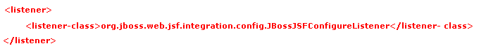

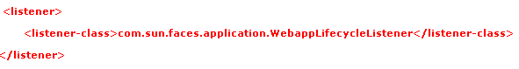

- Restart the server.

